Introduction to Amazon Elastic Compute Cloud (EC2)

Lab Details

1. This lab walks you through the steps to launch and configure a virtual machine in the Amazon cloud.
2. You will practice using Amazon Machine Images to launch Amazon EC2 Instances and use key pairs for SSH authentication to log into your instance. You will create a web page and publish it.
3. AWS Region: **US East (N. Virginia) us-east-1**

Introduction

What is EC2

* AWS defines it as Elastic Compute Cloud.
* It’s a virtual environment where “you rent” to have your environment created, without purchasing.
* Amazon refers to these virtual machines as Instances.
* Preconfigured templates can be used to launch instances. These templates are referred to as images. Amazon provides these images in the form of AMIs (Amazon Machine Images).
* Allows you to install custom applications and services.
* Scaling of infrastructure i.e., up or down is easy based on the demand you face.
* AWS provides multiple configurations of CPU, memory, storage etc., through which you can pick the flavor that's required for your environment.
* No limitation on storage. You can pick the storage based on the type of the instance that you are working on.
* Temporary storage volumes are provided, which are called Instance Store Volumes.  Data stored in this gets deleted once the instance is terminated.
* Persistent storage volumes are available and are referred to as EBS (Elastic Block Store) volumes.
* These instances can be placed at multiple locations which are referred to as Regions and Availability Zones (AZ).
* You can have your Instances distributed across multiple AZs i.e., within a single Region, so that if an instance fails, AWS automatically remaps the address to another AZ.
* Instances deployed in one AZ can be migrated to another AZ.
* To manage instances, images, and other EC2 resources, you can optionally assign your own metadata to each resource in the form of tags.
* A Tag is a label that you assign to an AWS resource.  It contains a key and an optional value, both of which are defined by you.
* Each AWS account comes with a set of default limits on the resources on a per-Region basis.
* For any increase in the limit you need to contact AWS.
* To work with the created instances, we use Key Pairs.

Architecture Diagram

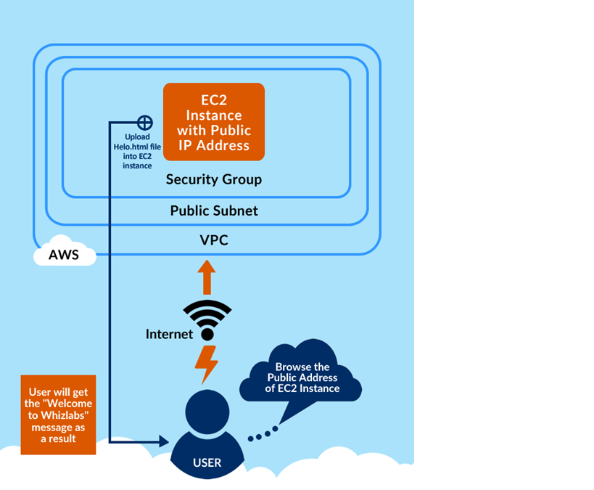

Task Details

1. Launching Lab Environment
2. Launching an EC2 Instance
3. SSH into EC2 Instance
4. Install an Apache Server
5. Create and publish page
6. Validation of the lab